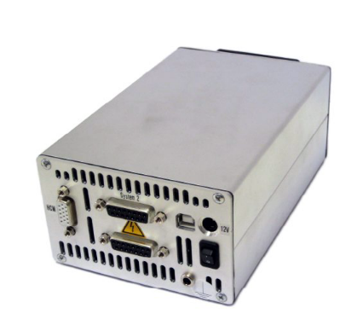

Smart Act Perfect Motion
(software controlling the Motors)

To be Able to control the motors using a computer the needed software is:
- MCS - Modular Control System
- MCS configuration Tool
- PTC - Precision Tool Commander

The cables are connected as shown in the figure:
- between MCS and computer is an Ethernet cable

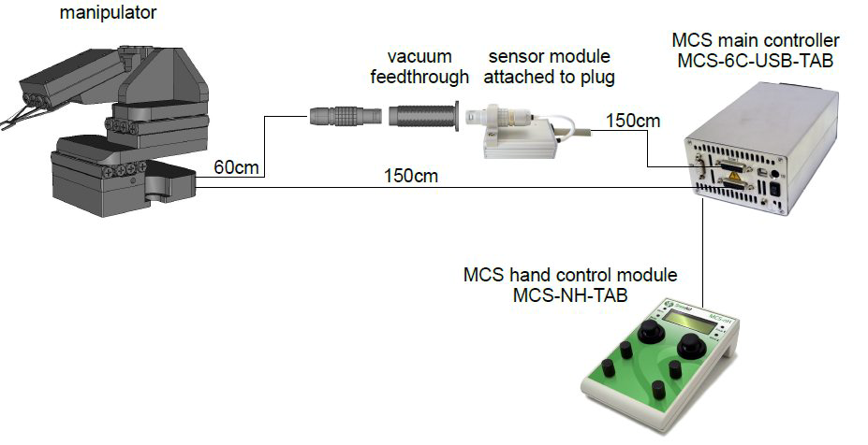

Or Replace with Computer

Notes Before setting up the software:
- careful when connecting the cables that are inside the cavity box as the bins are very fragile. It clicks when fixed, there is no rotation needed to fix the cable it.
- Connect them in away that is easy to track which is which.
A good example is shown in the photo below. The minicavcity bowtie mirrors are connected indicated.

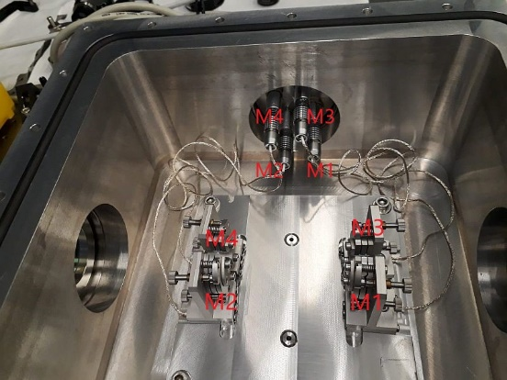

- The connections of the motors should be connected in sequence M1 – M2 – M3 – M4 with channels Ch0 – Ch1 – Ch2 – Ch3. This helps managing the motors on the software.
The photo below shows the order in which the mirror’s motors are connected with the channels and how they will be shown on the software.

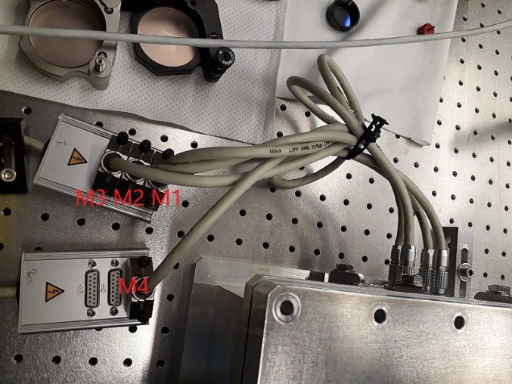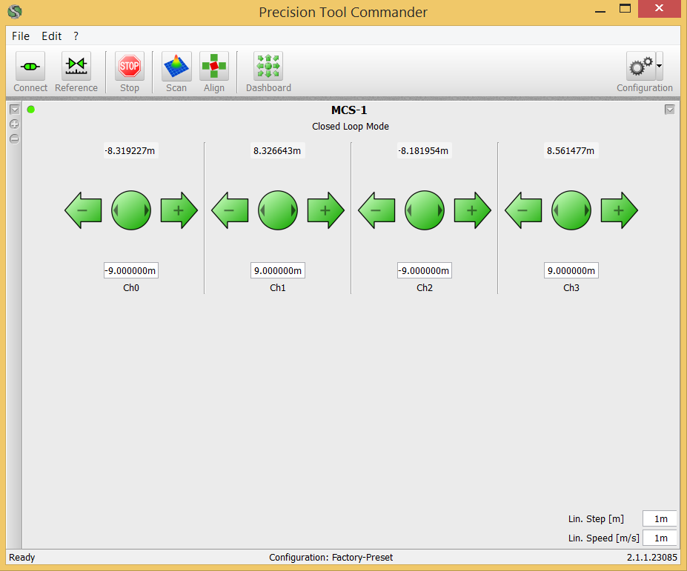
M1 M2 M3 M4 M

- The connection between the controller and the computer is an Ethernet connection which needs to be configured into the Network Connections portals in the computer (Procedure shown after)
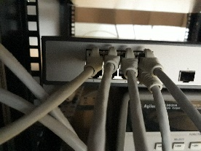

- Configuration of the Ethernet Portal:
Define the Network Connection portal that the software will use
  - From control Panel go to “Network and Internet” then chose “Network and Sharing Center”.
  - Choose from the side panel “Change adapter setting”, a new window will appear named “Network Connections”.
  - Right click on “Ethernet” and choose Properties, the properties window will appear.
  - In the “Networking” tab double click on “Internet Protocol Version 4 (TCP/IPv4)”, the properties window will appear.
  - In the “General” tab chose the option “Use the following IP address”.
  - Fill the “IP address” with (192 168 1 10) and the “subnet mask” with (255 255 255 0).
  - Click “Ok” the exit.

Photos bellow show the procedure.

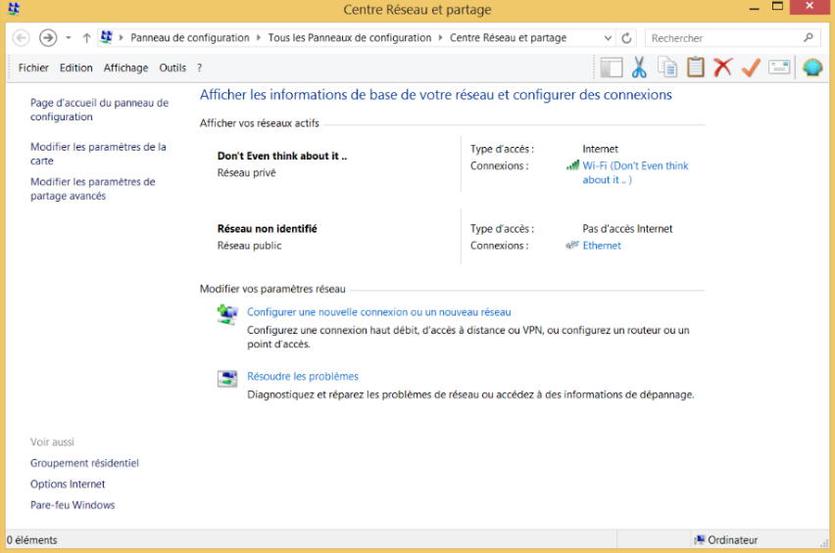

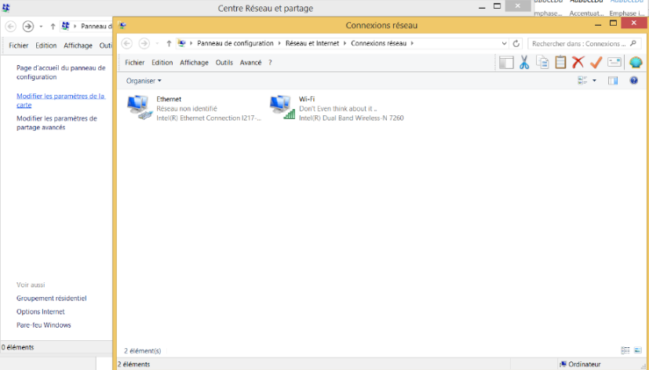

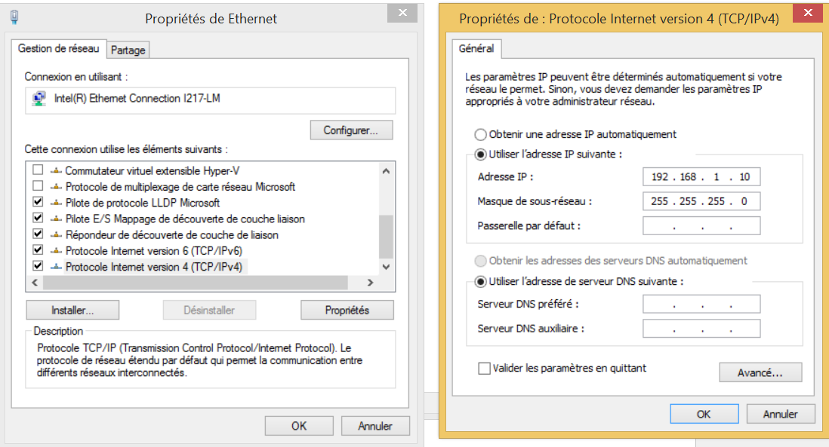

- MCS Configuration Tool:
Now you need to configure the controlling software to the specific Network connection defined previously.
  - Open the “MCS configuration Tool”
  - From “Connection” options chose “Select MCS” and write “Network:192.168.1.200:5000”
  - Click on “connect” the dot will be colored grey before connection after connecting it will change into “disconnect” and the dot will be colored green.
  - The connection is done.

Photos bellow specify the areas to change and confirmed connection.
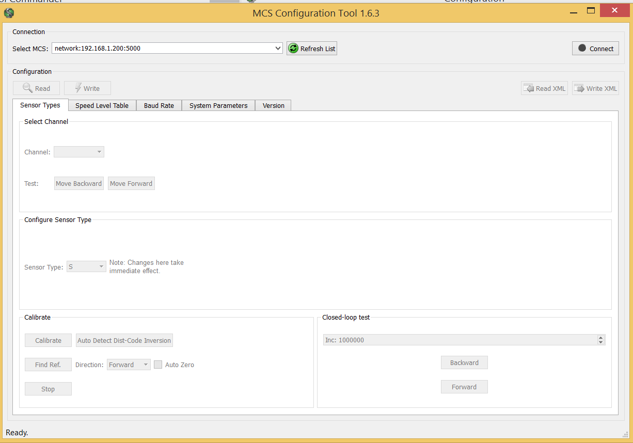
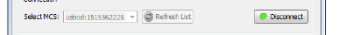

- PTC - Precision Tool Commander:
PTC is a graphical user interface (GUI) that supports you in controlling SmartACT MCS , This is what replaces the Hand Controller of the MCS.
- When opening the interface, the window will be empty, you will need to add devices such as controllers.
- In the window in the top right go to “Configuration”. In the new window you can add devices, specifically “MCS-1” controllers, and configure them.
- In our case of having 2 connection modules each with 3 ports, we can add up to 6 MCS controllers. But, we only require 4 for the mirrors.
- Add the Four channels, after that you need to reference and calibrate each one of them.
- Choose the “Sensor Mode” to be “on”
- For each Channel in “options” choose “Set Position to Zero at Reference”
- Then click “Reference”, it’s dot will be colored grey. If the referencing when will it will be green.
- Then Click on “Calibrate” for calibration.
- If both process where successful the “status” bar will go from “STOPPED” to “HOLDING”, its color will be Blue.
- After calibrating all dots should be green
******** Careful Note******
- In the channel settings set “Hold Time” = 60000, this will hold the position indefinitely.
- For “Frequency” its value is very important in Closed Loop Mode, having a very high value will give an error when referencing the channels. Set it to 5000
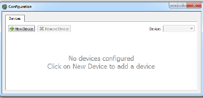
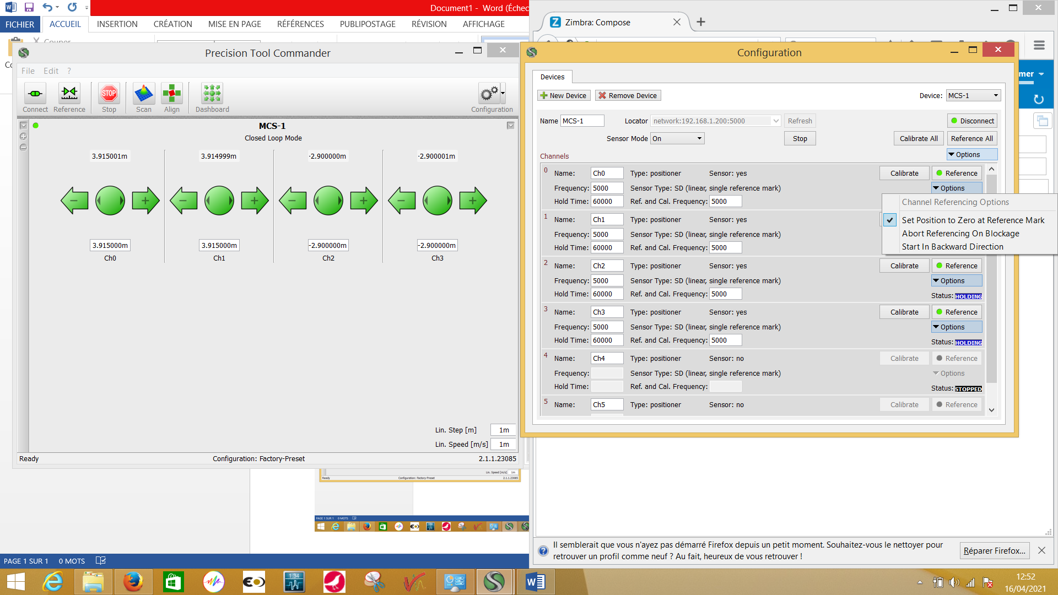

- For the Minicavity Mechanics
The Maximum values that the motors can physically move is shown in the Photos bellow.
Max all to the right of the cavity box facing us

Max all to the left of the cavity box facing us

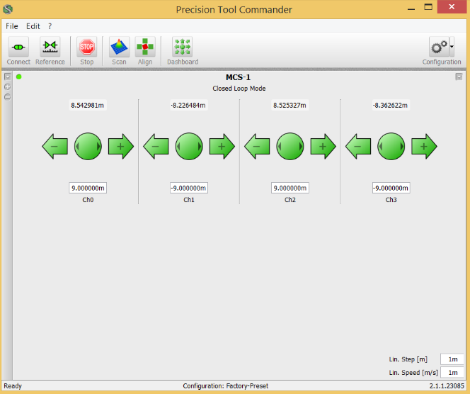

Set position of the mirrors at the moment
